# **1. Introduction**

## **1.1 Overview**

With the increased global demand for food security and consumption of fish protein, in Australia the consumer consumption of seafood based products currently exceeds the domestic production (AG, 2016a). The client has realised the potential for fish farming as one of the most efficient means of solving this problem. Currently Tasmania contributes to 50% of the seafood market in Australia and therefore already has the infrastructure and government subsiding for such a venture. The client has proposed an aquaponic fish farm of tilapia, in Little Swanport River Catchment. The fish farm will require a water treatment system designed for the client using several components to manage overflow, filtering, mixing, and heating. It will need to ensure the pond water stays at the set point temperature and pollutants are neutralized by mixing through a conditioner to form a homogenous mixture both thermally and chemically. The overall objective of this project is to design, simulate, and build a small scale prototype for the proposed aquaponic fish farm.

## **1.2 Aims**

The aims of this project are:

· To investigate engineering principles on flow splitter control systems, static in-line mixers, tensile members and material strain properties, and temperature control during processing and final stream.

· To design and produce a small-scale prototype, with full justification of choices and evidence of its feasibility through simulations.

# **2. Project Requirements**

The project scope will be dealing with creating a suitable prototype that meets the needs of the client to accurately control temperature and pollutants through filtering and mixing for an aquaponic fish farm.

## **2.1 Design Components**

Refer to table 1 for an overview of the project requirements and design problem.

|  |  |
| --- | --- |
| **Goals** | · Create a small-scale prototype that can effectively split a river water and hot water stream to a set-point temperature ·  · Effectively homogeneously mix the stream with a conditioner. |
| **Outputs** | · A working prototype that can filter water to the client’s standards.  · Justification for the design choices that meet the client’s requirements.  · A control system and a facility simulation that demonstrates the prototypes success under varying conditions. |
| **Needs** | · Design and fabricate a continuous flow splitter, a static inline mixer, a tensile member.  · Design, code and implement a functional control system.  · Select a hot water pump from the three provided by the client. |
| **Functions** | · Complete mixing shown by homogenous colour.  · Accuracy of temperature control through flow splitter and control system.  · Tensile member elasticity in conjunction with the strain gauge to give an accurate reading of volume in the batch tank to effectively stop the system. |

## **2.2 Assumptions**

The following assumptions have been made when considering the design problem:

· Thermal loss or gain within the system is considered negligible.

· For the law of conservation of mass it is assumed the water is incompressible and the density is constant, therefore mass in = mass out.

## **2.3 Elements in and out of scope.**

Table 2 refers to elements within the scope of the design process and those outside of the scope.

|  |  |
| --- | --- |
| **In Scope** | **Out of Scope** |
| · Design of flow splitter, mixer, and tensile member.  · Design of control system and facility simulation.  · Fabrication of components, calibration, and prototype testing of functions.  · Material selection for tensile member.  · Justification of pipe layout within the system.  · Features of the chosen pump.  · Complete mixing of water conditioner and hot and cold streams to achieve the set point temperature of 29◦C. | · The collection method for attaining river water.  · The water filtration system prior to the prototype phase.  · Water heater components and energy requirements.  · Injection system for water conditioner.  · System between batch tank and waterfall aeration to ponds.  · Fishponds and design and supply of hydroponic beds.  · The full-scale facility of the prototype. |

**3. SOLVEM Overview**

This is a problem-solving approach and is assigned the acronym SOLVEM.

**S**ketch

**O**bjectives or **O**bservations

**L**ist

**V**ariables

**E**quations

**M**anipulations.

This technique of problem solving is equivalently useful for difficulties involving estimations and more precise calculations. All the steps are described below.

**3.1 Sketch**

The Sketch illustrates, how the drawing of a problem helps you to visualize the problem. In sketching the situation, we are subconsciously thinking about it. One should be aware to draw the sketch large enough so that everything becomes clear and easy to think about. The labelling of the known things is also very important for a much clearer idea of the difficulty. In some situations, we can also make more than one diagram like the before-and-after set of diagrams.

In very complex situations we can also make intermediate diagrams as well.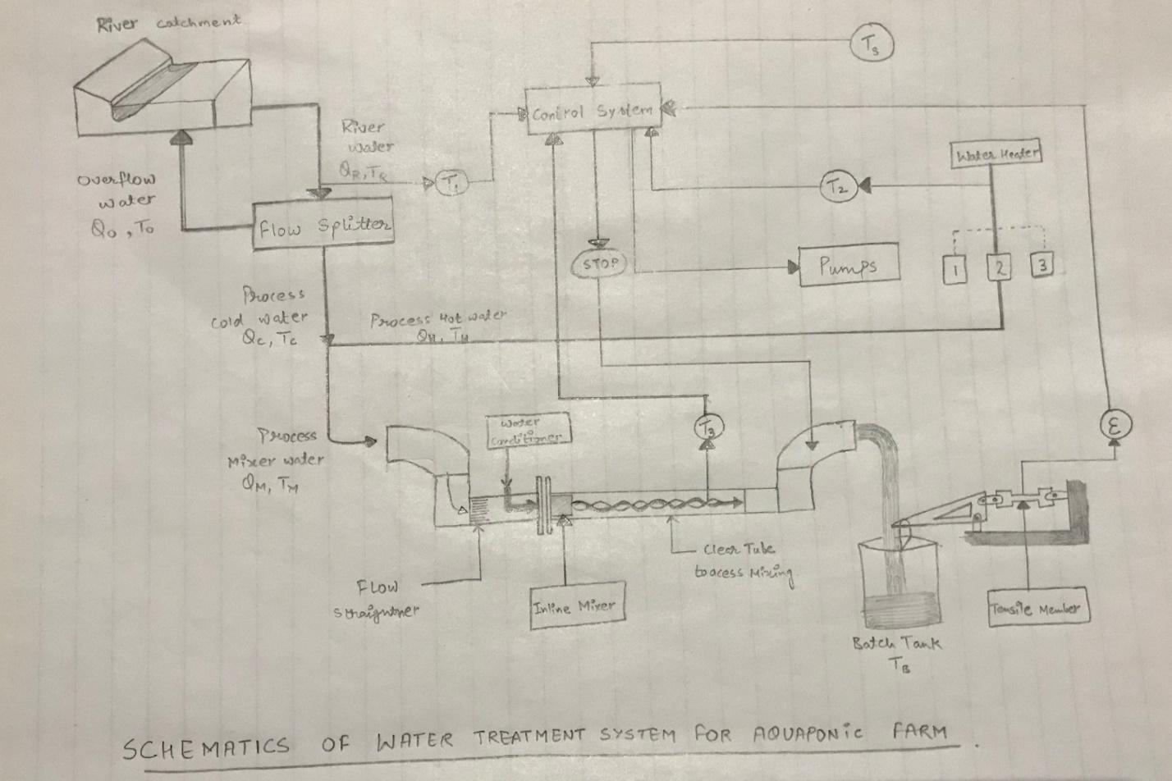

**Fig: SCHEMATICS OF WATER TREATMENT SYSTEM FOR AQUAPONIC FARM**

**3.2 Objectives and observations**

Objectives or Observations can be of the form of questions, simple statements or anything else that can make you familiar with the difficulty. This can also help in dividing the objectives and observations into different categories. Some of the most common things we can write are:

* Observations about the materials and their properties.
* Observations about the parameters like temperature and velocity which can’t be easily sketched.
* Objective about what needs to be achieved.
* Observations like size, shape and other geometry related problems.
* Several other diversified observations that are important as well.

Some of the typical examples of Observations and Objectives are:

**Objectives:**

* Build and demonstrate water treatment for a fish farm.
* Find the speed, distance, force, pressure, etc of flowing water.
* Fit the mixer and splitter into the right position.
* Calculating the resultant temperature of the water.
* Make a good coordinated control system.

**Observations:**

Observations can be:

* The river water ranges from 2-260C.
* The mass of Batch tank is 5Kg and volume is 12.5L.
* The set point temperature is in the range appropriate for tilapia fish.
* The pond water ranges from 27-310C.

While observations can also be related to materials and their properties like:

* The melting point of aluminium is 660.30C.
* Plastic will float on water.
* The value of gravity is 9.8 m/s2.
* Water boils at 100 degree Celsius.

**3.3 List of variables and constants**

In this part, we need to go over the observations section and then list all the variables that are important. The list can be divided into several broad categories such as those related to the geometry problems, the problems related to materials and their properties, and some problems comes under those categories that may not be appropriately defined is above mentioned categories. We need to include the name of the variable, the symbol; used to denote it, and the value of the variable (if known), including the units. The constants can also be listed. Refer to appendix for list of variables and important constants.

**3.4 Equations**

Only after completing the first four steps one should think of writing down the equations that will manage the problem. It is helpful to make the list of relevant equations before writing down the particular expressions. Example:

* Mass and Energy relations.
* Conservation of mass.
* Newtons law of cooling.
* Hooke’s Law.
* Density Equations.
* Strain equations.

Writing down of sub equations is also important like:

|  |  |
| --- | --- |
| **Expression** | **Equation** |
| Density | Mass/ Volume |
| Conservation of energy | Qc = -QH |
| Energy (mass relation) | Mass . (speed of light)2 |
| Transferred energy | mc Δt |
| stress | Force/ area |
| Viscosity | Stress/ velocity gradient |
| Flow rate | Volume per unit time |

The values are not to be substituted in this part of the process. Instead, manipulate the equations into the desired form algebraically.

**4.5 Manipulation**

Directly substituting the values into the equations is not a good practice. We will often observe that some of the terms cancel each other and returns a simple equation to deal with. By doing this practice we will:

* Be able to decide whether final equation is consistent or not.
* Be less likely to make mathematical mistakes.
* Obtain general expression which can help to solve similar problems.
* Be able to effectively understand the result.

The process of SOLVEM helps to analyse the problem and obtain an expression that will help us to find the numerical answer.

An example of the manipulation method is represented by the conservation of energy

equation used to solve for the temperature of two mixed streams of water is shown below;

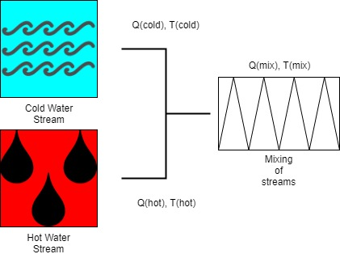

Conservation of energy is represented by -q1 = q2

Manipulated using the above variables-

Q(cold)xT(cold) + Q(hot) x T(hot) = (Q(cold) + Q(hot)) x T(Mix)

Rearranged to find T(mix):

Q(cold)xT(cold) + Q(hot) x T(hot)/ (Q(cold) + Q(hot)) = T(mix)

**4.6 Representing the answer**

After completing all the steps of the SOLVEM, plug in all the values of the variables and the constants, and solve the equation to get the final answer. The final answer must contain a numeric value and its units. Additionally, it is also useful to write some sentences that describes how the answer meets the desired objectives. Box the final answer for the easy identification.

Repeating the SOLVEM process several questions helps to attain deep level understanding about the analysis of problems by making us think about the generalities of the problem before jumping in and searching for the right equation. This is an efficient method to rely on.

## 

## **5. Prior Art**

**Analysis of static in-line mixers**

The purpose of the static in-line mixer in the prototype is to provide a homogenous solution of water conditioner and processed water at the set-point of 29◦C. The purpose of a static mixer is to manipulate fluid streams to divide, recombine, spread, and swirl to achieve a high degree of mixing. The water conditioner substitute chosen for the prototype is dyed glycerol. Glycerol has 3 hydroxyl groups, therefore one molecule can form at least 6 hydrogen bonds and thus the intermolecular forces are much greater than that of water, resulting in the higher viscosity. Another example of this is the molecule H2SO4 (Doan, D.H. et al. 2011). This makes Glycerol 1500 times more viscous than water at 35◦C (Dickey, D. 2015). The characteristics of a static mixer is that it contains no moving parts, reducing maintenance, and two streams of substances to be combined into a thermal and chemically homogenous solution. The basis for the intermixing interaction is the pressure of a single stream being pumped into the mixer with the addition of a second stream which forces the particles of the two streams to maintain high velocity, which when they reach a critical Reynolds number, the particles intermolecular forces begin to form a uniform consistent mix (Trejo González, Longinotti and Corti, 2011).

When considering the design of a static inline mixer, the best mixer is the one that achieves the required degree of homogeneity, with the most efficient pressure drop, for the lowest cost, and finally fits the desired system. To achieve mixing without a static mixer would result in the requirement of an impractical length of piping to achieve what the mixer can in about 10cm (Trejo González, Longinotti and Corti, 2011). To determine the best current inline mixer design, an analysis was performed on the current commercially available mixers, a summary table of the top four designs and a brief description is shown below (For full analysis see appendix 1);

|  |  |  |
| --- | --- | --- |
| **Type of Inline mixer** | **Commercial example of mixer** | **Functions of mixer** |
| Double Roof Disc mixer | (StaMixCo, 2007) | This type of mixer uses a monolithic structure to mix and disperse viscous liquids of different volumetric flows and viscosity. In terms of the clients requirements this design could effectively provide a homogenous solution given the evidence provided by commercial testing done by StaMixCo, with the design achieving an average of 99% degree of mixing based on chemicals with 1:9 and 1:100 viscosities and flow rates. (StaMixCo, 2007) |
| X-grid static mixer | (StaMixCo, 2007) | This variation of inline static mixer uses X-grid crossing bars to provide a mixing of homogenous fluids of different viscosities over a shorter length than the Helical mixer design. With success mixing different viscosities of 1 million:1 and different volumes of 1000:1, as well as being effective and thermal homogenisation. An example of this comparison can be seen in Appendix 1. (link pic)(Invotec, 2013) |
| Helix mixer | (StaMixCo, 2008) | The helical designed mixer is pioneered as the most cost effective design with moderate mixing capabilities in comparison to the last two examples. The design consists of alternating-twist helical spirals similar to a bow tie. It is most effective in a laminar flow and can be scaled to fit the dimensions of any piping without losing structural integrity or mixing efficiency. (StaMixCo, 2008) |
| Corrugated plate mixer | (StaMixCo, 2006) | This design uses a varying amount of corrugated mixing plates across the pipe diameter with the mixing created by 45◦ angled corrugations relative to the pipe axis, adjacent mixing elements are then rotated 90◦ along the same axis to maintain three dimensional mixing. Its main application is in turbulent flow systems, mixing low viscosity liquids and creating thermally homogenise mixes. The example shown left is an example of how the design an increase the mixing intensity by adding additional mixing plates, however this sacrifices pressure in the system thus a spacer may be required to maintain steady flow between mixing elements, thus increasing cost of this design. (StaMixCo, 2006) |

The client requires the designed static inline mixer fit within a flange connected to the prototype rig, this flange has an inside diameter of 30mm, thus using commercially available data on the required dimensions of a design to maintain effective mixing efficiency. An example of this is the double roof mixer design, that with data provided by StaMixCo, the required dimensions of a polypropylene inline mixer to fit with a 30mm flange are an outside diameter of 29.6mm, an inside diameter of 21mm, the length of each mixing component as 13.4mm and the minimum requirement of eight adjacent mixers resulting in a total length of 107.2mm (StaMixCo, 2007). These dimensions can be altered based on the degree of homogeneity needed (Appendix 2) and the maximum allowable pressure drop (Appendix 3) for the client’s requirements (Jaya. A, 2014).

To determine the best mixer the design team will draw up all four of these chosen designs and a simulation will be performed to determine the design best suited for this project.

**Flow Splitter Investigation**

The purpose of a flow splitter is to divert water from an input and into two or more outputs, or vice versa. For this project, the objective of the flow splitter is to take a flow of river water and separate it into two paths; a cold river water path to processing and an overflow path.

There are two main methods for splitting a flow. These are the storage or reservoir method and the flow restriction method. (St Louis Sewer District, 2018) The storage method involves an amount of water being stored within the body of the flow splitter, before it is divided and output to the paths. (St Louis Sewer District, 2018) The process cold water path needs a very specific flow rate and must be as accurate as possible for the system to function properly. The reservoir method will not be able to be used because flow rates will not be able to be set accurately enough by the control system.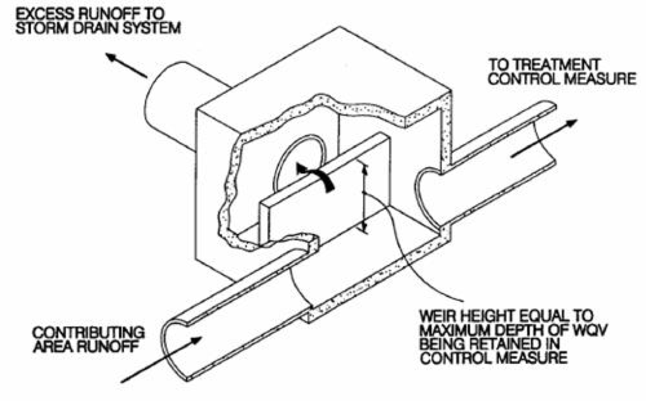

The flow restriction method will allow control of flow rates of process cold water and overflow. Input to the flow splitter will have flow rates and temperatures varying between 2 – 8L/min and 2 – 26C°, depending on outside conditions. (Edwards, 2018) Process cold water capacity is 2.5L/min and when river flow exceeds this, overflow will be collected in the gutter and delivered back to the river. (Edwards, 2018) When the input to the flow splitter is less than 2.5L/min, all of the input will be used as process cold water. The design will need to be able to maintain a constant flow for process cold path, while any excess flow to be directed to the overflow outlet.

However, simply splitting the path into two identical paths may not be sufficient enough to allow accurate control over flow rates for project. Resistances and pressure can cause vastly different flow rates in each path. (Trinkel, 2009) Therefore, a weir system could be used. Figure _ shows how a weir would function within a flow splitter. This would allow for any overflow input above that of the process capacity amount, will go over the weir wall and be delivered to the gutter. By using this method, pressure differences could be compensated for. Below is a comparison of a few key flow splitter sub types and their suitability for the project.

Priority flow divider - Always has the same flow rate for the control path, while excess flow can be deposited as overflow. (Trinkel, 2009)

Spool flow divider - Works on pressure balancing and compensation.

* Harder to control flow rates. (Trinkel, 2009)

Rotary flow divider - Acts like two pumps, with shafts joined, rotating at the same speed. This causes equal flows through each path.

- Often used for oil flows.

- May have many outlets. (Womack, 2018)

**Flow Splitter Materials**

The flow splitter must be designed such that it can fit in a 240x240mm housing. The material used to fabricate the flow splitter will need to have a number of properties in order to function well. It will need to be

· strong,

· stiff,

· cheap,

· durable,

· able to get wet

· easy to manufacture.

Table 3 shows two material types that may be suitable for use as the main material for the flow splitter. Note that a composite material may also be a viable option.

Table 3: Flow splitter material options

|  |  |  |
| --- | --- | --- |
| Material | Pros | Cons |
| Metals | - high mechanical strength  - stiff  - cheap  - easy to manufacture | - may be vulnerable to corrosion when exposed to water for periods of time. |
| Polymers | - able to get wet and resist water.  - cheap  - easy to manufacture  - light weight | - not very stiff or strong  - not stable at high temperatures |

**Tensile Member**

The tensile member is a crucial component in determining the volume of conditioned water in the batch tank, it also utilises a strain-gauge to route a signal to the control system once the desired strain threshold is reached. *Figure 1* denotes the connection between the tensile member and the batch tank.

The tensile strength of a material refers to the amount of force it can withstand before rupture. The batch tank will exert a maximum applied stress load of 92.93 Pa (Equation 1, Appendix 5) which is sufficiently below the maximum tensile strength of all 3 materials. Aluminium has a decreased tensile strength relative to that of the PVC or acetal, only being able to withstand 11 MPa (Bestech,2018).

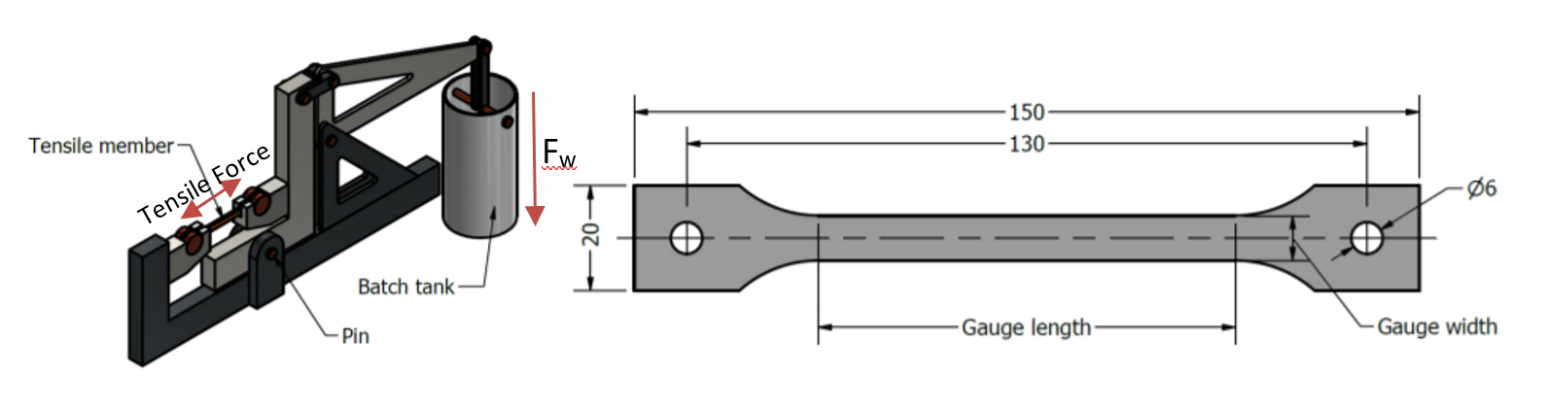



|  |  |  |
| --- | --- | --- |
| **Proposed Materials** | **Tensile Strength (MPa)** | **Young’s Modulus (GPa)** |
| PVC | 52 | 2.8 |
| Acetal | 65 | 3.5 |
| Aluminium | 11 | 25 |

Table 1 Young's Modulus (Engineering ToolBox, 2005.)

Young’s modulus is the measure of elasticity for a given material. It determines the amount of stretch/deformation before a material breaks under either tensile or compressive forces. Aluminium has a significantly greater Young’s Modulus than that of PVC or Acetal with many aluminium alloys exceeding 100 GPa (MatWeb, 2018).

The ideal material for the tensile member should consist of a high tensile strength and a low young’s modulus, this allows for the best measure of flex (strain-gauge) whilst maintaining the structural integrity of the tensile member.

### **Hot water Pump**

The water within the pond is required to remain at 40 – 60◦C and the flow rate of the water will vary depending on the temperature of the pond water. Three pumps have been pre-selected to choose from: The RS MG500-180-12, Shurflo 8000-542-136 and the Linix MG317.

The RS MG500-180-12 model operates through a magnetic drive centrifugal system which works by substituting the traditional direct drive mechanism with a magnetic field. The magnetic field then drives an impeller which spins the liquid to the outlet pipe via centrifugal forces providing a smooth flow and a sealed water proof design. The pump is also reliable due to the lack of parts in contact with one another. The operating temp of the pump ranges between -20◦ to 100◦C and the listed dimensions are as followed 64 x 32 x 31mm. The pump also requires a high pressure to prevent the water being pumped from vaporizing causing wear on the impeller (Known as Cavitation).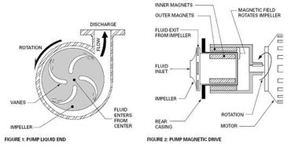

Figure 1, How a Magnetic Drive pump works, source: <http://www.tmagpumps.com/how-it-works-magnetic-drive-pump>

The Shurflo 8000-542-136 Diaphragm Pump works on the same principles as a piston. Cycled expansion and contraction of the chamber cause the pump to draw the water in and then discharge it as the diaphragm contracts. Diaphragm pumps generally have an outstanding reliability due to the lack of contact points within the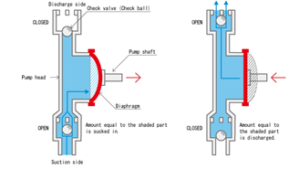

pump thus the operating cost over time is reduced. The Shurflo pump operates at 60PSI and has an open flow rate of 6.8 Litres per minute. The diaphragm design of the pump doesn’t allow for a smooth flow of the liquids but does allow for heavier materials to be pumped.

Figure 2, How a Diaphragm pump works, source:https://www.tacmina.com/learn/basics/01.html

The Linix MG300 uses a gear pump mechanism which functions by way of two gears that mesh in such a way to block the passage in between the gears. Thus, the gears must spin in opposite directions to carry the liquid around the gears towards the outlet pipe. This is achieved by only applying drive into one gear thus forcing the other gear to turn in the opposite direction. The MG300 uses a magnetic drive system to rotate the gear thus it can be assured that the drive system will be reliable. The pump operates in temperatures ranging from -10◦ to 100◦C and a flow rate between 1000 to 6000 mL per minute. It also has an expected life time listed at 8000+ hours.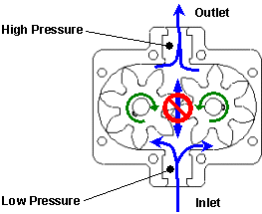

Figure 3,Section view of a Gear pump, source: http://web.mit.edu/2.972/www/report-gear_pump.html

All three pumps work effectively through different pumping mechanisms. The RS MG8000 will most likely be selected due to its good reliability and operating temperatures but pre-cautions must be taken to prevent cavitation from occurring.

## **Control System Investigation**

A feedback control loop may use a number of physical and computational components to regulate a system’s performance in real time. (Astrom, 2008) A basic feedback loop consists of two components, the control and the process. (Astrom, 2008) The control is fed signals from sensors at the start of the system and the process output near the end of the system. The control will consider these input signals in accordance with a pre written algorithm and implement a change to one or more system variables, in an attempt to achieve the system’s desired output. (Astrom, 2008)

In relation to our project, the control system has two general purposes. The first is to “regulate flow of hot water to obtain the set-point temperature of mixed process water.” (Edwards, 2018) To attain this, the control component of the feedback system will receive signals from three temperature sensors. Two sensors are located pre water mixing, retrieving temperatures of cold river water and hot water from the pump, and one post mixing, for the temperature of the mixed water. An algorithm, programmed using Simulink software, will use this information to increase, decrease or cease the hot water pumping, until the desired temperature (set by a fourth temperature signal to the control) is achieved at the output.

The other main use of the control system is to “stop water discharge when batch volume is reached.” (Edwards, 2018) The control will receive signal data from a strain gauge on the tensile member. As the batch tank becomes more and more full (closer and closer to 10L), strain on the tensile member will increase. A Simulink algorithm will use the strain data to calculate the level of the batch tank. When the control receives a signal saying the batch tank is full, it will deactivate the system and stop processing.

A feedback control system will be a very suitable and useful tool for the project. It will enable the system to work autonomously, without the need for physical interference.

**Analysis of behavioral systems**

To determine how the model and system will behave through the designed control system and a facility simulation a modelling-based simulation program will be used, Simulink. This is a cost-effective way to automate design workflow for our model. The purpose of the facility simulation is to verify the control algorithms used in the control model of the system through several different variables, assessing the steady-state and dynamic performance of the system. This simulation modelling also allows for the simulation of faults and hazardous conditions that would otherwise be costly and damage the model with a physical simulation (MATLAB, 2018). An example of the synergy between the control system and behavioural simulation is given below.

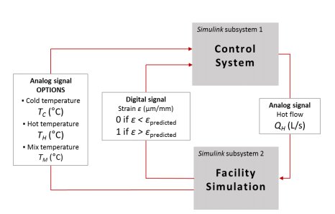

(Edwards, G. et al. 2018)

The simulation of the operating conditions of the system will model the effectiveness of the control system and the design by altering the variables such as river temperature and flow over a one-year period. This modelling will show how the system can handle river water overflow and how the control system will adapt to the amount of hot water and cold water needed to reach the required mixing temperature set-point of 29 degrees, via the flow splitter. This modelling would be in conjunction with modelling the hot water pump system under the set variable conditions. To reach the required temperature for the system, modelling combining the hot water profile and the river water profile to determine the effectiveness of the flow splitter and the control systems associated with this component. A large component of this modelling is determining the effectiveness of the temperature sensor control algorithms, and to determine the accuracy of the temperature control during processing. To complete this assessment of the proposed system various measurement checkpoints and relays will be tested to determine the flow and temperature control during processing. To make the simulation of the system manageable it is assumed thermal loss or gain by the system is negligible based on the conservation of energy assumption.

## **6. Project Management**

* 1. 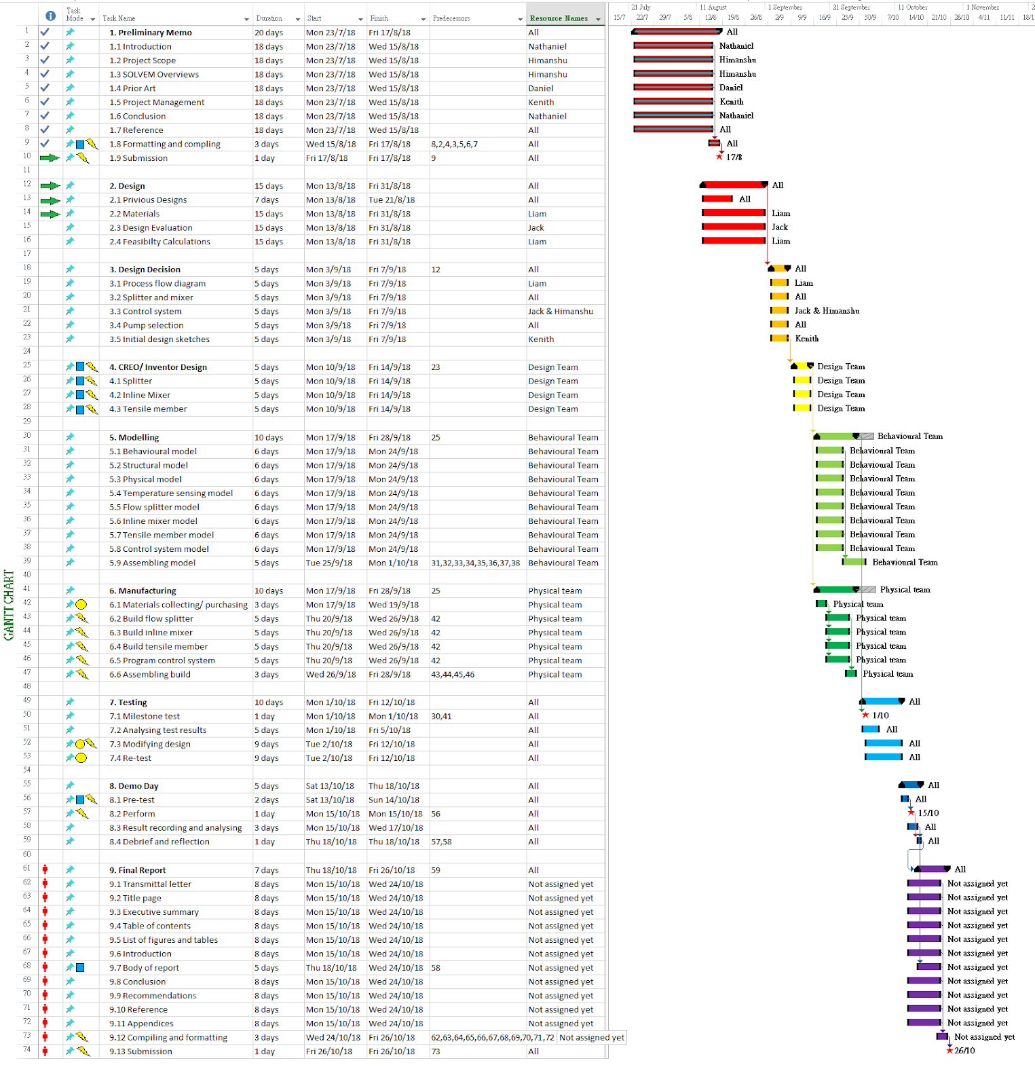**GANTT CHART**

|  |  |
| --- | --- |
| **LEGEND** | |
| https://lh4.googleusercontent.com/9YhRq9LE9rRNqTwC9Jg2H9b_vje3YRYfu-lIyAxWZfYmsezNfBL3RGOPC71Qz6wVyxUEZci6nyqJtHL87BItkxymNqRkWtI9iv_qF8V0ti0srh-jVZTCc83Cykh0SnnqsknrbMnoAG7hkASbMg | Tasks in progress |
| https://lh3.googleusercontent.com/hPFFb50YuCzoXyHw3LeHXX9ctEf0TXHT_asWA2iwgI-CJdjb-moTG-buFkbaj1N4NTFdBLSc1ZFHwx_AEpRXzouqHVEfHkRNzWW4S7VEYqmN6N1jMbo4aOfHeX_87yM71yIdgdMiWujSidrFaA | Tasks to be finish for the project |
| https://lh4.googleusercontent.com/A0TYqibSKkJ8TqmcBjs01eiCkPH9PZ28zrQ-XkvnGoslHHCAQQ4Pe5WWi7WZ-h5rwJfULPANnRlOCPfOuoSq6OU7KNzS-lHelI5G8U0qnNNe1K0SI4lYL77ykjQY0SASB3EVboX9uqwmxMWKiQ | Tasks finished |
| https://lh3.googleusercontent.com/8b7ZoB94Oa9WohYD5c8l9GMXo0DHEfRS2Y40Svqo7DX_96mocKyj0KQ-GIzfUvfvVYPa9w0PKPugFf7B-Bb9ZDgCkj3Kov5rN-8bg09zRgyTpFSFok9PcctiqUXqzqfm2mVaWGw-3YFSbIH81Q | Additional time allowed for tasks to be completed after the dead-lines |
| https://lh6.googleusercontent.com/LNOeTCXGPXLNEi3jScDDHP5FT4yrOe-P5aWt-UYkL2oweU4Wzqdl7slJUiMqz2lV9rOE1UiSX1CMOBlWfiPGoaIJG9DyKenBuXcDtVitrgrKYOKjMmVHQBebsr5Lv026UDP28vrLx5clpa29KQ | Milestones/ important tasks |
| https://lh6.googleusercontent.com/4Rwf4kojTys7lf-gAQBebQVrihngb-VyO8kZoLcqHPvHgpZpqCtwBwwoDprAoLWG82WJ2C3Yt7zBnCXzL0rXA5aGHp1mOAuBRhkuG2ReIqlhNBs-C44hCDTjIG8OTc0pWCE_5j6C-X0xD0RHBA | No people assigned risk |
| https://lh3.googleusercontent.com/uLexXrxRTb2KErCkvhALef7wxx7hC_Kt7JJw3dUbKE2yB03-5ZSF4veLHNIxv0jfdFrR4406iGFlqt9aK3g-XOaiv5kFAtpwOOULFZoojCDdpHbRlapjs0GtF_Qw1YCkH2Lq6cYjcm-FTces8Q | Budget risks |
| https://lh5.googleusercontent.com/Cl6ZoSDsh_lYA9D05FwOiUA3cwTn7ygO3-BOaeiLgzTWkkXdFYvYKrPyW7wPZf4sosXriVFFySRD43Gmexvs6cMHhJM4jWJItw_D0s23TfvTJWPknMn1fGJipOop6mrM65EUuAZxqd7rgzOjvQ | Technical risks (mechanical/ computational) |
| https://lh3.googleusercontent.com/rtfGzPQ74mXToDgFASV21zzbx4DlH2Wg2k_3svxSYAdzsdNFHsnOsA0ohHfoRulwVQ73GTKTgsEBTis7Y-hoxhmNxUUbPFoF_wNHC0f-HHE7_LFMc7LG7759KjvCBMDCutX3sSDHkHa5RjnRYg | Time duration risks (tasks may not be completed before dead-lines) |

https://docs.google.com/drawings/d/smgMADo7BsNLgsrk_0AybTA/image?w=197&h=37&rev=1&ac=1&parent=1-5fQ75tADDWZqHaIGYPnzlifOM-l2NRqzf7kU-yhU1U

**6.2 Risk Assessment**

|  |  |  |  |  |  |  |
| --- | --- | --- | --- | --- | --- | --- |
| **Risk description** | **Possible Consequence(s)** | **Possibility of Risk** | **Severity of Risk** | **Risk rating** | **Control measures** | **Residual risk** |
| Pipes pumping hot water maybe exposed to people | People may get in contact with the hot surface and potentially get slightly burnt. | IMPROBABLE | TOLERABLE | 4 | Keep people away from the hot pipes. Stick “HOT” warning signs on hot surfaces. |  |
| Electric wires are not properly organised across the test field | Electrocution may happen if someone get in contact with exposed electric current. Tripping might also happen | IMPROBABLE | UNACCEPTABLE | 7 | Organise wires properly away from people, use cable tie strips and cover any exposed wire with insulator. |  |
| Systematic error or miscalculation in Simulink and wrong coding. | The system may fail to carry out the correct action. Unpredictable action may occur. | IMPROBABLE | UNACCEPTABLE | 7 | Have a monitor system monitoring any undesirable action at all time. Create a “STOP” button for termination of the system. | If the system even fails to follow the “STOP” function, something uncontrollable may happen. |
| The batch tank may be accidentally knocked over | Slippery ground, slipping accident may occur | PROBABLE | TOLERABLE | 6 | Keep clear from the tank, possibly make a closed tank. |  |
| The assembly of the system (pipes) is not fully secured and improperly connected. | The system may fall apart during the process. River water and hot water may spill out. | IMPROBABLE | UNACCEPTABLE | 7 | Always double check all the connections before running the system | The connection bolts and screws may be damaged already. |
| The continuous flow splitter fails to divert water to overflow, thus excess water flows into the system non-stop. | Excessive water may overload the system and causes malfunctions in valves and pumps. Pipes leakages or explosions might occur. | POSSIBLE | UNACCEPTABLE | 8 | Have an automatic/ manual (person) monitor system at all time on the Qo and Qc. | Manual monitoring may not be completely reliable. |

Table 2 – Risk Assessment

**4.2.2 Legend**https://docs.google.com/drawings/d/sjyDAGaOnf42X1cOTDCgixA/image?w=243&h=38&rev=1&ac=1&parent=1-5fQ75tADDWZqHaIGYPnzlifOM-l2NRqzf7kU-yhU1U

|  |  |  |  |  |
| --- | --- | --- | --- | --- |
| **Severity**  **Possibility** | **ACCEPTABLE**  **Almost no effect** | **TOLERABLE**  **Effects are felt** | **UNACCEPTABLE**  **Serious effect** | **INTOLERABLE**  **Disastrous effect** |
| IMPROBABLE | Low  =**1** | Low  =**4** | Medium  =**7** | High  =**10** |
| **POSSIBLE** | Low  =**2** | Medium  =**5** | High  =**8** | Extreme  =**11** |
| **PROBABLE** | Low  =**3** | Medium  =**6** | High  =**9** | Extreme  =**12** |

* 1. 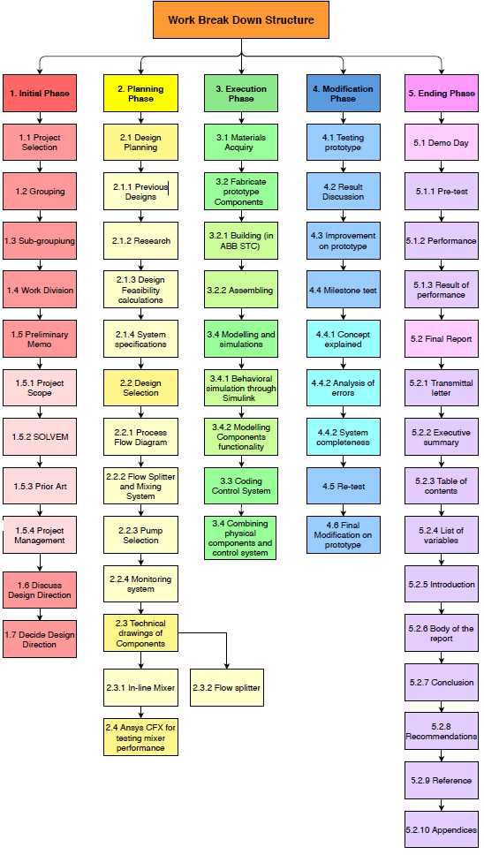**Work Breakdown Structure (WBS)**

**6.4 OVERVIEW OF RESOURCE ALLOCATION**

|  |  |  |  |
| --- | --- | --- | --- |
| **Tasks/ resource** | **Allocated member** | **Allocated time** | **Allocated budget (AUD$)** |
| 1. ***Preliminary Memo*** | All | 20 days | 0 |
| 1. ***Design*** | All | 15 days | 0 |
| 2.1 Previous Designs | All | 7 days | 0 |
| 2.2 Materials | Liam | 15 days | 0 |
| 2.3 Design Evaluation | Jack | 15 days | 0 |
| * 1. Feasibility Calculations | Liam | 15 days | 0 |
| 1. ***Design Decision*** | All | 5 days | 0 |
| 3.1 Process flow diagram | Liam | 5 days | 0 |
| 3.2 Splitter and mixer | All | 5 days | 0 |
| 3.3 Control system | Jack & Himanshu | 5 days | 0 |
| 3.4 Pump selection | All | 5 days | 0 |
| 3.5 Rough Design Sketches | Kenith | 5 days | 0 |
| 1. ***Professional Design*** | Kenith & Himanshu | 5 days | 0 |
| 4.1 Flow splitter | Kenith & Himanshu | 5 days | 0 |
| 4.2 Inline mixer | Kenith & Himanshu | 5 days | 0 |
| 4.3 Tensile member | Kenith & Himanshu | 5 days | 0 |
| 1. ***Modelling*** | All | 10 days | 0 |
| 5.1 Behavioural model | Jack & Liam | 10 days | 0 |
| 5.2 Structural model | Jack & Liam | 10 days | 0 |
| 5.3 Physical model | Jack & Liam | 10 days | 0 |
| 1. ***Manufacturing*** | Nathaniel & Daniel | 10 days | **100** |
| 6.1 Purchase/collect materials | Nathaniel & Daniel | 3 days | **100** |
| 6.2 Build prototype | Nathaniel & Daniel | 5 days | 0 |
| 6.4 Assemble prototype | Nathaniel & Daniel | 3 days | 0 |
| 1. ***Milestone test*** | All | 10 days | 0 |
| 1. ***Improvement*** | All | 9 days | **100** |
| 1. ***Demo Day*** | All | 5 days | **20** |
| 1. ***Final Report*** | All | 7 days | 0 |

## **References**

Edwards, G. et al. (2018) Document 3, ENGG1200 course material, The University of Queensland.

Edwards, G. et al. (2018) Document 2, ENGG1200 course material, The University of Queensland.

Acoustic Properties of Poorly Cemented Sandstones Under Temperature And Stress - Scientific Figure on ResearchGate. Available from: https://www.researchgate.net/Changes-in-dynamic-viscosity-of-glycerol-with-temperature-Water-viscosity-is-about-0001_fig2_273132151 [accessed 15 Aug, 2018]

Au.mathworks.com. (2018). Model-Based Design- MATLAB & Simulink- MathWorks Australia. [online] Available at: https://au.mathworks.com/help/simulink/gs/model-based-design.html [Accessed 15 Aug. 2018].

Dickey, D. (2015). Tackling difficult mixing problems. [online] Aiche.org. Available at: https://www.aiche.org/sites/default/files/cep/20150835.pdf [Accessed 15 Aug. 2018].

Jaya, A. and Kolmetz, K. (2012). STATIC MIXER (ENGINEERING DESIGN GUIDELINE). [online] KLM Technology, pp.1-23. Available at: http://kolmetz.com/pdf/EDG/ENGINEERING_DESIGN_GUIDELINE_static_mixer_Rev02web.pdf [Accessed 15 Aug. 2018].

Mixers.com. (2018). [online] Available at: https://www.mixers.com/insights/mti_70.pdf [Accessed 15 Aug. 2018].

Mochizuki, N., Kaide, A. and Saeki, T. (2018). Quantitative Evaluation of Mixing Characteristics of Static Mixers by Visualization Experiments. Journal of Flow Control, Measurement &amp; Visualization, 06(01), pp.27-38.

Schneider, G. (2013). Static Mixing Technology For Extrusion and Injection Molding.

StaMixCo (2006). Static Mixing Elements for Mixing/Dispersing of Viscous Fluids. [online] WinterThur. Available at: http://www.staticmotionlessmixers.co.uk/assets/gxm-static-mixers-for-viscous-fluids.pdf [Accessed 15 Aug. 2018].

Trejo González, J., Longinotti, M. and Corti, H. (2011). The Viscosity of Glycerol−Water Mixtures Including the Supercooled Region. Journal of Chemical & Engineering Data, 56(4), pp.1397-1406.

St Louis Sewer District. (2018). Flow Splitting Design Criteria. Retrieved from: https://www.stlmsd.com/sites/default/files/engineering/412621.PDF

Trinkel, Bud. (2009). Flow Divider Circuits. Hydraulics & Pneumatics. Retrieved from: https://www.hydraulicspneumatics.com/other-technologies/book-2-chapter-11-flow-divider-circuits

Barbaro, H. et al. (2004). Storm Water Handbook. Department of Environmental Protection. Retrieved from: http://prj.geosyntec.com/npsmanual/flowsplitter.aspx

Astrom, K. (2008). Feedback Systems. Princeton University Press, Oxfordshire.

Bb, 2018f. Sheet Aluminium – Technical Data Sheet. ENGG1200 Blackboard 2018, Project B. [Accessed 12/08/2018].

Bestech Sensors and Teaching Equipment. (2018). Modules of Elasticity – Youngs Modulus in common materials. Retrieved from: https://www.bestech.com.au/modulus-of-elasticity/ [Accessed 13/08/2018].

Vinidex. (2016). PVC Properties. Retrieved from: http://www.vinidex.com.au/technical/material-properties/pvc-properties/ [Accessed 14/08/2018]

Engineering ToolBox, (2005). Stress, Strain and Young's Modulus. [online] Available at: https://www.engineeringtoolbox.com/stress-strain-d_950.html [Accessed 15/08/2018].

MatWeb. (2018). Aluminium, AI. Retrieved from: http://www.matweb.com/search/datasheet.aspx?bassnum=AMEAL00&ckck=1 [Accessed 16/08/2018].

Womack, (2018). A Study of Roatary Type Flow Dividers. Retrieved from: https://www.womackmachine.com/engineering-toolbox/data-sheets/a-study-of-rotary-type-flow-dividers/

Edwards, G. et al. (2018). Classification of Materials, ENGG1200 course material, The University of Queensland.

T-Mag Mag Drive Pumps (2017). Magnetic Drive pump – how it works. Retrieved 09/08/2018, from T-Mag Magnetic Drive Pumps: [http://www.tmagpumps.com/how-it-works-magnetic-drive-pum](http://www.tmagpumps.com/how-it-works-magnetic-drive-pump)p

Pittsburgh Spray Equipment Company (2018). Diaphragm pump, Pros and Cons. Retrieved 15/08/2018, from Pittsburgh Spray Equipment Company: <https://www.pittsburghsprayequip.com/2017/11/15/diaphragm-pump-pros-cons/>

Premier Fluid Systems (2018). Advantages and Disadvantages of Magnetic Drive Pumps. Retrieved 15/08/2018, from PFS Pumps: <https://www.pfspumps.com/advantages-and-disadvantages-of-magnetic-drive-pumps/>

Tacmina (2018). What is a Diaphragm Pump. Retrieved 12/08/2018, from Tacmina: <https://www.tacmina.com/learn/basics/01.html>

Culpepper, Martin L. How a Gear Pump Works, Retrieved 15/08/2018 from MIT: <http://web.mit.edu/2.972/www/report-gear_pump.html>

**Appendices**

Appendix 1- modified from Jaya, A. 2014

|  |  |
| --- | --- |
| **Types of mixers** | **Description** |
| KMS | Twisted ribbon or bowtie type, with alternating 90 degree twists to the pipe axis. |
| KMX | Series of curved rods forming an X lattice, mixing elements are rotated 90 degrees to the pipe axis. |
| SMV | Corrugated sheeting running at 45 degrees to the pipe axis, mixing elements rotated 90 degrees along the same axis. |
| SMX/SMXL | Guide vanes using intersecting bars at 45 or 30 degrees to the pipe axis. |
| KVM | Each mixing element is a single inline tab mounted on the mixer wall. |
| ISG | A solid tube insert that forms a tetrahedral mixing chamber with holes drilled at oblique angles for flow. |

Analysis of above designs, modified from Jaya, A. 2014

|  |  |  |  |  |  |  |
| --- | --- | --- | --- | --- | --- | --- |
| **Flow Regime** | **Static Mixer Design** | | | | | |
| KMS | KMX | SMV | SMX/SMXL | KVM | ISG |
| **Laminar** | | | | | | |
| Mixing | C | A | - | C | - | A |
| High-Low viscosity |  | A | - | C | - | A |
| Dispersion | A | A | - | A | - | A |
| Heat transfer | C | - | - | B | - | - |
| Plug Flow | B | - | - | B | - | - |
| **Turbulent mixing** | | | | | | |
| High turbulence | A | - | C | - | C | - |
| Low turbulence | C | - | C | A | - | - |

Legend: A= applicable, B = typically applied, C= Best design choice for this flow.

Appendix 2

The quantitative mixing performance can be assessed through calculating the factor of reduction in inhomogeneities as shown below:

The standard deviation starting at the first mixing element (initial) to the 8th mixing element (final);

Initial S0= 1.0 then S= 0.16, thus mixing efficiency is S/S0= 0.16/1 = 0.16

Factor of reduction = f = S0/S = 1/0.16 = 6

Thus for 8 mixing elements the colour concentration and temperature difference from the initial to the final mixing element is a factor of 6. (Mochizuki, Kaide and Saeki, 2018)

Appendix 3

The maximum allowable pressure drop can be calculated using the following equation:

∆p = 4/π x NeReD V/D3 x n nme/2

Where n = viscosity, NeReD values can be found online for particular commercial designs. (Schneiger. G, 2013)

Appendix 4

Image from (StaMixCo, 2006)

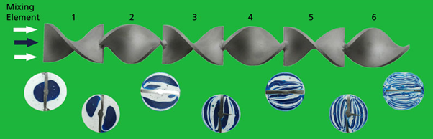

Appendix 5

Calculating maximum applied load of tensile member. (Engineering ToolBox, 2005.)

*Σ = Fn/A*

Where:

*Σ* = Normal stress (Pa(N/m2))

Fn = Normal force acting perpendicular (N)

A = Cross-sectional Area (m2)

### **Equation 1:**

*Σ = Fn/A*

Let Fn = m × a

Where:

m = 11kg (Assuming 10kg of conditioned water has entered the batch tank with mass 1kg.)

a = 9.8m/s2

Fn = m × a

Fn = 11 × 9.8

Fn = 107.8 N

Substitute Fn into *Σ =*

*Σ = 107.8/A*

Calculate A:

L × W + L × H (Length and width of Gauge used.) (Bb, 2018f)

|  |  |  |  |  |  |
| --- | --- | --- | --- | --- | --- |
| Width (mm) | W1 | W2 | W3 | W4 | W5 |
| L × W + H × L | 80×10.5+3.0×80 | 80×11+3.0×80 | 80×11.5+3.0×80 | 80×12+3.0×80 | 80×12.5+3.0×80 |
| A | 1080mm2 | 1120mm2 | 1160mm2 | 1200mm2 | 1240mm2 |
| *Σ =* | 99.81 Pa | 96.25 Pa | 92.93 Pa | 89.833 Pa | 86.93 Pa |

Appendix 6: list of variables and important constants

|  |  |  |
| --- | --- | --- |
| **Symbol** | **Variable** | **Units** |
| w | Tensile member gauge width | mm |
| T0 | Temp. of overflow water. | 0C |
| ε | Strain signal. | μ m/m |
| QM | Flow of mix process water. | L/min |
| TM | Temp. of mix process water. | 0C |
| TB | Batch Temperature. | 0C |
| TC | Temp. of cold process water | 0C |
| TH | Temp. of hot process water | 0C |
| TP | Temp. of fish ponds | 0C |
| TR | Temp. of river water | 0C |
| TS | Set point temperature. | 0C |
| Ti (I = 1,2,3) | Temp. of probe signals. | 0C |
| Lsg | Length of strain gauge | mm |
| mBT | Mass of batch tank | Kg |
| Qc | Flow of cold process water | L/ min |
| Qh | Flow of hot process water | L/ min |
| QM | Flow of mixed process water | L/ min |
| QO | Flow of overflow water | L/ min |
| QR | Flow of river water | L/ min |
| ρG | Density of glycerol | Kg/ L |
| ρW | Density of water | Kg/ L |
| μ g | Dynamic viscosity (glycerol) | Pa·s |
| μ w | Dynamic viscosity (water) | Pa·s |
| VB | Batch volume | L |
| VBT | Volume of batch tank | L |
| c | Specific heat | J/ Kg K |

**Some of the properties we can think about are:**

|  |  |  |
| --- | --- | --- |
| **Property** | **symbol** | **Value** |
| Density of water | (ρ) | 997[kg/ m3] |
| Specific gravity | (sg) | 1.34 |
| The spring constant | (k) | 0.051[N/ m] |
| Dynamic viscosity(water) | (μ w) | 8.90 × 10−4 Pa. s |
| Dynamic viscosity(glycerol) | (μ g) | 1.412 Pa·s |